1. For first Read [Click](https://quatr.us/china/invented-paper-ancient-china.htm)
2. For second page 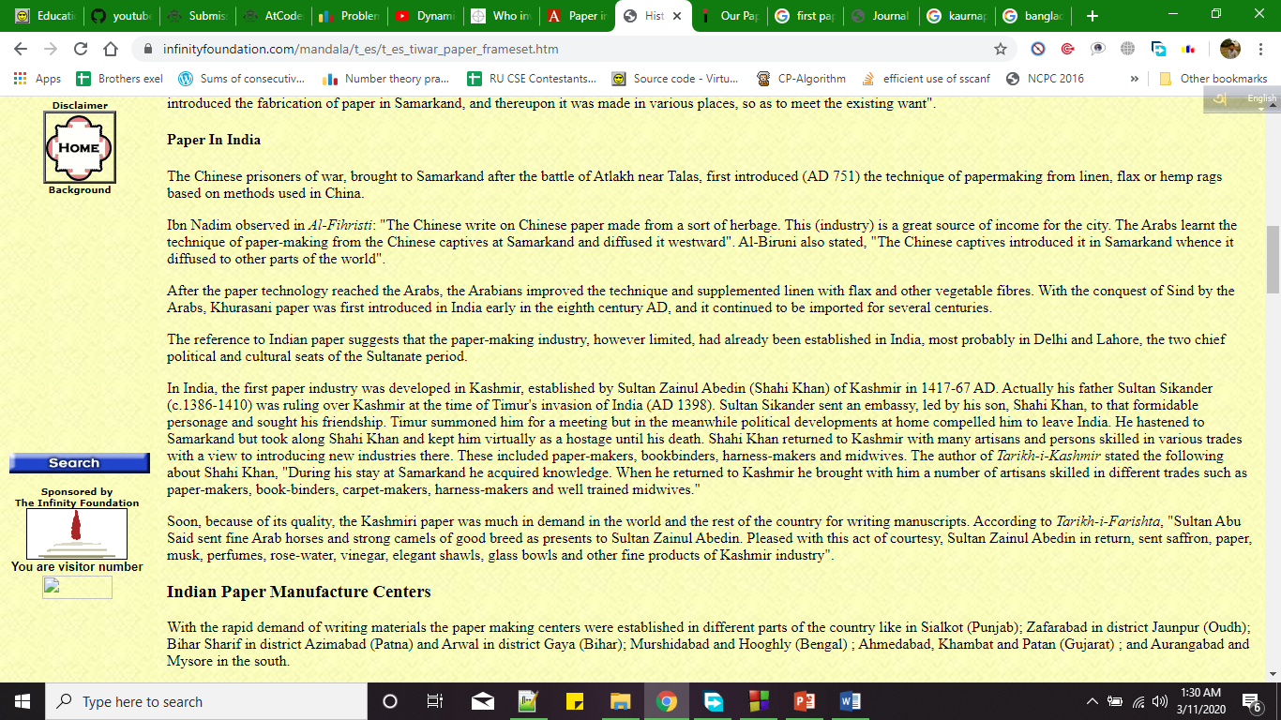
3. For 3rd and 4th page [click](http://www.theindependentbd.com/printversion/details/139544)

And only the first page of the pdf [click](https://www.banglajol.info/index.php/JCE/article/view/10181/7536)